|  |  |  |
| --- | --- | --- |
| NursingALD.com - A Free Online Resource for Nurses  **Echo/Vascular Laboratory**  **Call Policy**  **and**  **Hours of Operation** | Prepared by:  Maya Hutchinson, RDCS (AE/PE), RVT, RDMS, Former Clinical Supervisor,  Technical Director | Revised by:  Kaitlyn Russum, RDCS (AE), RVT, RDMS (AB/OBGYN), Cardiovascular Sonographer |
| Approved by:  Dr. Erica Salinas, MD  Dr. John Boyer, MD  Dr. Hector Orlando Heredia, MD | Review/Revise dates:  1/21/2010  01/21/2020  11/28/2021 |
| Effective date:  5/21/2022 | Page 1of 10 |

1. **Policy:**

Echo/Vascular Laboratory After-Hours/Weekend/Holiday and Stat Ordering

1. **Purpose:**

To establish policy and procedure for after-hours, weekend, holiday, and stat ordering of echo and vascular studies. It is the policy of the Boone Hospital Center Echo/Vascular Laboratory to operate during normal business hours, **Monday through Friday from 08:00-17:30**, except for the following holidays: Memorial Day, Fourth of July, Labor Day, Thanksgiving and Black Friday, Christmas Eve and Christmas Day, and New Year’s Eve, New Year’s Day, and potentially observed holidays.

This policy is to provide a continuum of quality care for the patients and employees of BHC.

Boone Hospital Center Echo/Vascular Laboratory is a full service lab offering comprehensive diagnostic cardiology and vascular ultrasounds as well as noninvasive peripheral vascular testing. Our goal is to provide accurate and necessary examinations in a timely manner, while also considering sonographer well-being and retention.

1. **Procedure for Inpatients, New Admits, and Outpatients:**
   1. All inpatient (IP) studies ordered are considered routine unless otherwise indicated by the **ordering physician**. All IP orders placed within normal business hours will be completed within 24 hours. All inpatient orders are completed based on priority; ICU, Stepdown and COVID + orders are considered more urgent, followed by the oldest to newest orders (See Appendix A).
   2. In the event of a surplus of inpatient orders at the end of the business day that cannot be completed within 24 hours of the order date, staff is responsible for calling the ordering/attending physician to receive verbal consent that a study may wait to be completed until the following business day. Otherwise, the sonographer on call will be responsible for completing studies that must be completed same day. If an ordering physician cannot be reached, the study in question will be pushed to the next business day.
   3. All outpatient (OP) studies requested during normal business hours will be referred to the scheduling department to be scheduled in a timely manner, unless the study is considered emergent.
      1. Urgent and emergent indications for an OP echocardiogram include pending chemotherapy treatment, pericardial effusion and chest pain. Other qualifications for emergent OP status include pre-op studies for surgery the next day, post-op timed studies, venous duplex studies for DVT, or any study needing done for an acute onset of symptoms.

Staffing and OP openings will determine if an emergent OP study can be performed. All emergent OP studies needed outside of normal business hours should be referred to the Emergency Department (ED).

* 1. Any routine IP studies left over from Friday are to be performed by the on-call sonographers over the weekend. IP studies ordered on weekends/holidays are considered to be routine unless otherwise indicated and will be performed on the following Monday (or first open business day). **Weekend/holiday “STAT”**/need same day IP or ED echocardiogram orders will need a cardiologist consultation before the sonographer should be called. **Weekend/holiday “STAT”**/need same day IP or ED vascular ultrasound orders (with the exception of UE or LE venous duplex studies- See Appendix B) will need a vascular surgeon consultation before the sonographer should be called. If the cardiologist or vascular surgeon agrees an echocardiogram or vascular ultrasound is emergently needed, the on-call echo and/or vascular sonographer must be called or paged by the **ordering physician**. (See Appendix A). “Shock” is the only indication for a “STAT” echocardiogram that does not require a cardiologist consultation prior to completion.
  2. **Weekend/Holiday “Urgent”** **IP or ED echocardiogram** orders will be completed within 12 to 24 hours of the order date to allow for coordination with other testing and/or procedure(s). “Urgent” status studies must be called to the on-call echo sonographer. To be ordered “urgent”, the indication must meet one or more “urgent” criteria (See Appendix A, Fig. 3).
  3. **Weeknight STAT** **IP or ED echocardiogram** orders will need a cardiologist consultation before the sonographer should be called. “Shock” is the only indication for a “STAT” echocardiogram that does not require a cardiologist consultation prior to completion. **Weeknight STAT IP or ED vascular ultrasound** orders (with the exception of UE or LE venous duplex studies- See Appendix B) will need a vascular surgeon consultation before the sonographer should be called.
  4. Pending discharge IP studies requested outside of normal business hours should be referred to the scheduling department to be completed on an outpatient basis. In the case of **diagnosed cryptogenic stroke**, carotid and echocardiogram studies may be requested by the neurology/stroke team and should be completed prior to discharge.
  5. If a holiday falls prior to an adjoining weekend, the first day of the holiday will be the only day any leftover routine inpatient studies from the day/night before will need to be completed by the on-call sonographers. Each subsequent day, the sonographer will only be responsible for STAT/need same day studies or “urgent” status echocardiogram orders (to be completed w/i 12 to 24 hours). If a holiday is a two-day holiday, leftover studies can be done on either day, as long as they are completed before the following call shift (if adjoining weekend) or next business day.

1. **Procedure for ED and IP DVT Studies**
2. **Lower/Upper Extremity venous ultrasound imaging for DVT (See Appendix B)**
   1. To maximize the clinical yield of DVT studies, providers should use an algorithm (see Appendix B) employing a Well’s score (Fig. 4) and d-dimer to determine the need for and timing of venous ultrasound imaging for DVT.
   2. A low probability Well’s score and negative d-dimer generally justifies no further venous ultrasound imaging for DVT.
   3. A high probability (≥ 3) Well’s score alone may justify anticoagulation, if not otherwise contraindicated, prior to venous ultrasound imaging for DVT.
      1. **ED**: If the patient is being admitted and anticoagulated for PE and/or high probability DVT, then venous ultrasound imaging may be performed routine during normal business hours.
      2. **IP**: if an IP is anticoagulated for PE and/or high probability DVT, then venous ultrasound imaging may be performed routine during normal business hours.
   4. Patients with an intermediate probability Well’s score or with a positive d-dimer need venous ultrasound imaging to confirm the need for anticoagulation.
   5. When a patient with contraindication to anticoagulation presents (Fig. 5) with moderate or high risk of DVT, it is better to confirm the need for alternative treatment and not delay venous ultrasound imaging.
3. **Lower/Upper Extremity venous ultrasound imaging for DVT in the ED with delayed venous ultrasound imaging (See Appendix B, Fig. 4 and 5)**
   1. After business hours in the ED, if no contraindication to anticoagulation exists, the provider can reasonably provide a bridge of lovenox (1mg/kg SC bid or 1.5 mg/kg daily) and arrange venous ultrasound imaging for the next day. If the next day falls on a weekend or holiday that the Echo/Vascular Lab is closed, then venous ultrasound imaging should not be delayed.
   2. For delayed venous ultrasound imaging, ED providers should:
4. Provide an adequate bridging dose of anticoagulation
5. Ensure reliable follow-up to provide further anticoagulation should the study demonstrate a DVT
6. Notify the vascular lab (voicemail at ext. 3441) to expect the patient

i. Echo/Vascular Lab responsible for notifying scheduling to expect patient on OP basis

1. Complete DVT worksheet (Pg 10) for next-day and fax to 6428 and 8510
   1. When a provider cannot ensure reliable follow-up, then it is better to confirm a need for treatment during the ED visit and not to delay venous ultrasound imaging.
      1. If a need for venous ultrasound imaging in the ED is determined after normal business hours, the patient must be in an exam room and fully prepped for the upper extremity or lower extremity study **prior to** the on-call vascular sonographer being called. Additionally, the on-call vascular sonographer must be paged by the **ordering physician**. The on-call vascular sonographer may ask if there is a contraindication to the lovenox protocol (Fig. 5) if the Echo/Vascular department is open the following day.
2. **Arterial studies, including carotid, extremity, and visceral vascular studies, will not be routinely performed outside of normal business hours.** Any arterial study felt to be emergent after hours must be ordered/approved through the vascular surgeon on call and paged to the sonographer on call by the **ordering physician.**
3. **The only diagnoses that are emergent and time sensitive for echocardiograms outside of normal business hours are to assess for pericardial effusion if tamponade is suspected, to assess for right heart strain in a patient with confirmed or highly suspected pulmonary embolism, or to evaluate a patient in shock.** All orders for an echocardiogram felt to be emergent after hours must be ordered/approved through the cardiologist on call and paged to the sonographer on call by the **ordering physician**. “Shock” is the only indication for a “STAT” echocardiogram that does not require a cardiology consult prior to completion.
4. **Documentation:**

It is important that all studies, especially emergent studies, carry an appropriate symptom or diagnosis. This enables the sonographer and interpreting physician to provide the most comprehensive exam possible.

**Appendix A- Inpatient Orders**

When a physician places an **inpatient order** for an echocardiogram or vascular ultrasound, when should it be completed?

Studies are prioritized by status, patient location and how long ago the order was placed. This flow chart is to educate and establish an expectation for when studies will be completed, and if a study qualifies to be performed after normal working business hours (8am-5:30pm M-F) or days when the department is not staffed (weekends and observed holidays).

Order placed after normal working business hours or when department is not staffed?

Did the ordering physician order the exam as “STAT”?

Order placed after normal working business hours or when department is not staffed?

YES

NO

Order placed during normal business hours?

Order placed during normal business hours?

**B.**

Did the ordering physician order the exam as “Urgent”?

This exam will be prioritized and completed as soon as possible as time and staffing permits

Is a cardiologist or vascular surgeon the ordering physician?

YES

Page on-call echo and/or vascular sonographer

NO

Studies will be completed based on priority. ICU, COVID +, and Stepdown orders are considered time sensitive. All studies are completed with the oldest orders prioritized. All studies will be completed within 24 hours.

NO

YES

Any routine echo or vascular ultrasound will be completed on the next business day

**A**.

Is the order for an echocardiogram?

Is the order for an echocardiogram?

NO

YES

If a study cannot be completed within 24 hours of when the order was placed, the ordering physician will be paged to allow the study to be pushed to the following business day

NO

YES

Is the indication “shock”?

Echoes ordered in an “Urgent” status will be completed within 12 to 24 hours of the order date, but must meet “Urgent” criteria (See Fig. 3)

If an order is placed on a Friday or the day prior to an observed holiday and cannot be completed before the end of the workday, it will be performed over the holiday(s) or weekend directly following

Refer to Box B and follow decision tree

NO

YES

Consult on-call cardiologist or on-call vascular surgeon

Page on-call echo and/or vascular sonographer

Indications for performance of “Urgent” Echocardiogram:

1. Heart failure: no echo w/i 6 months
2. New cardiac arrythmia
3. Myocardial infarction
4. RV strain in setting of acute PE

Study assumed to be routine (see box A.)

Does cardiologist or vascular surgeon recommend STAT echo or vascular ultrasound be performed? ­

NO

YES

Page on-call echo and/or vascular sonographer

**APPENDIX B**

Algorithm for treatment of ED and inpatients with suspected DVT

Lovenox 1-1.5 mg/kg- actual body weight

Well’s clinical probability score (see Figure 4)

High (≥3)

Low (0) or Intermediate (1-2)

D-dimer test

Negative <0.5pg/ml

Positive >0.5pg/ml

During regular business hours

After regular business hours

No DVT

Order venous duplex for DVT

Negative

Positive

Contraindication to outpatient anticoagulant therapy? (See Figure 5)

No

Yes

Arrange venous duplex next morning*

During regular business hours

Order venous duplex for DVT

Inpatient

ED patient

Currently anticoagulated?

No

Yes

Long-term anticoagulation or vascular consultation

No emergent need for DVT study

Order venous duplex for DVT

Negative

Positive

No DVT

Long-term anticoagulation or vascular consultation

*If the Echo/Vascular Lab is closed the following day (weekend and/or holiday), the Lovenox protocol/delayed venous ultrasound imaging cannot be carried out.

FIGURE 3: Indications for performance of “Urgent” Echocardiogram

* Heart failure
  + No prior echo within 6 months
* New cardiac arrhythmia
* Myocardial infarction
* RV strain in the case of acute pulmonary embolus

FIGURE 4: How to calculate Well’s score

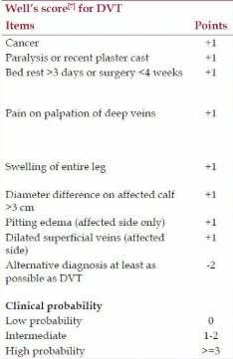

Pulivarthi S, Gurram MK. Effectiveness of d-dimer as a screening test for venous thromboembolism: an update. *N Am J Med Sci*. 2014;6(10):491–499. doi:10.4103/1947-2714.143278

Contraindications to Lovenox protocol (Fig. 5)

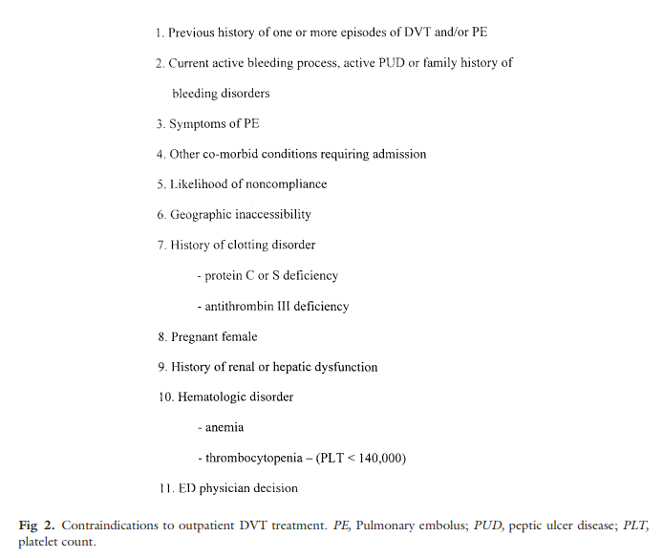

Langan EM 3rd, Coffey CB, Taylor SM, Snyder BA, Sullivan TM, Cull DL, Youkey JR, Gray BH. The impact of the development of a program to reduce urgent (off-hours) venous duplex ultrasound scan studies. *J Vasc Surg*. 2002 Jul;36(1):132-6. doi: https://doi.org/10.1067/mva.2002.125021

___________________________________________ ________________________________

Interim Technical Director, Jess Vestal Date

___________________________________________ ________________________________

Medical Director, Erica Salinas MD Date

____________________________________________ ________________________________

Medical Director, John Boyer MD Date

_________________________________________ _____________________________

Emergency Department Director, Hector Date

Orlando Heredia MD



kg

Exam to be done: ____________________________________________________________________

(Must be Monday-Friday)

9:00am-11:00am on

Diagnosis: ___________________________________________________________________________

*Fax to the Vascular Lab at 6428 and Centralized Scheduling at 8510